Exciting new results have been obtained for the time reversal portion of the self-healing project. We have continued to use a setup similar to what we have been testing. This setup involves the use of two solid, circular rod segments as the transmission medium and 3 ceramic piezoelectric transducers for sending/receiving signals. We sandwich one PZT between the two rod segments (defect PZT), then place the a PZT on each open end of the rod system (Ch0 and Ch1). We are pleased to state that we have been able to perform tests on non-dispersive media (steel rods) and dispersive media (nylon rods). The basic setup diagram for the tests is shown below. Also, the rod segments used are of two very different lengths such that the defect PZT is at an arbitrary location within the rod system (versus in the middle). Having the defect at an arbitrary position will further support the robustness of the time reversal algorithm that is used.

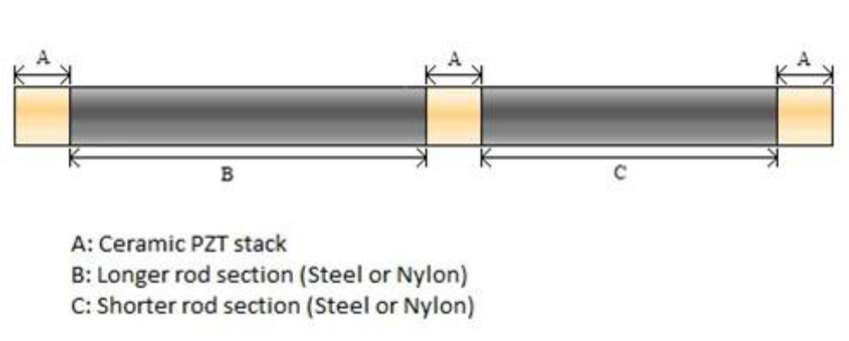
Figure 1 Basic diagram of the time reversal setup that is being used

There have been changes made to the time reversal algorithm that have given good results. As before, Ch0 transmits a pulse through one of the rod segments. This pulse propagates down the rod and splits upon reaching the defect PZT. A portion of the wave reflects back to Ch0 and a portion continues towards Ch1. These signals are recorded. Before, we would use a windowed normalized correlation to find the segment of the recorded signal for each channel that we would want to reverse. Now, we take the a windowed RMS of each signal recorded and search for the first large peak in the windowed RMS. In Ch0’s recorded signal, this first peak should correspond to the first occurrence at Ch0 of the reflected portion of the original pulse. For Ch1’s recorded signal, it will correspond to the first occurrence at Ch1 of the transmitted portion of the original pulse. A signal segment encompassing the time at which the peak occurred is selected for each channel. We wait a period of time for the ringing in the system to die down. Each segment is then time-reversed, amplified, and resent. The delay times for the pulses to reach the defect PZT are automatically inserted using this algorithm. These delays cause the segments sent from each channel to reach the defect PZT at the same time, thus causing a focusing of their energy. After these waves combine at the defect, their energy will again split apart with a portion headed to Ch0 and a portion headed to Ch1. Ch0 and Ch1 record this new signal information and extract, time reverse, amplify, and resend a segment of their recorded signals in the same manner as before. This time, however, the signals recorded are of higher quality and are likely to reach the defect PZT in a more efficient matter. In this fashion, the signals segments sent from each channel are iteratively focused at the defect PZT; each iteration giving a slightly better focusing than the previous iteration. After some time, the algorithm converges and the focusing ceases to improve beyond its current level. The new flowchart for the algorithm used is shown in

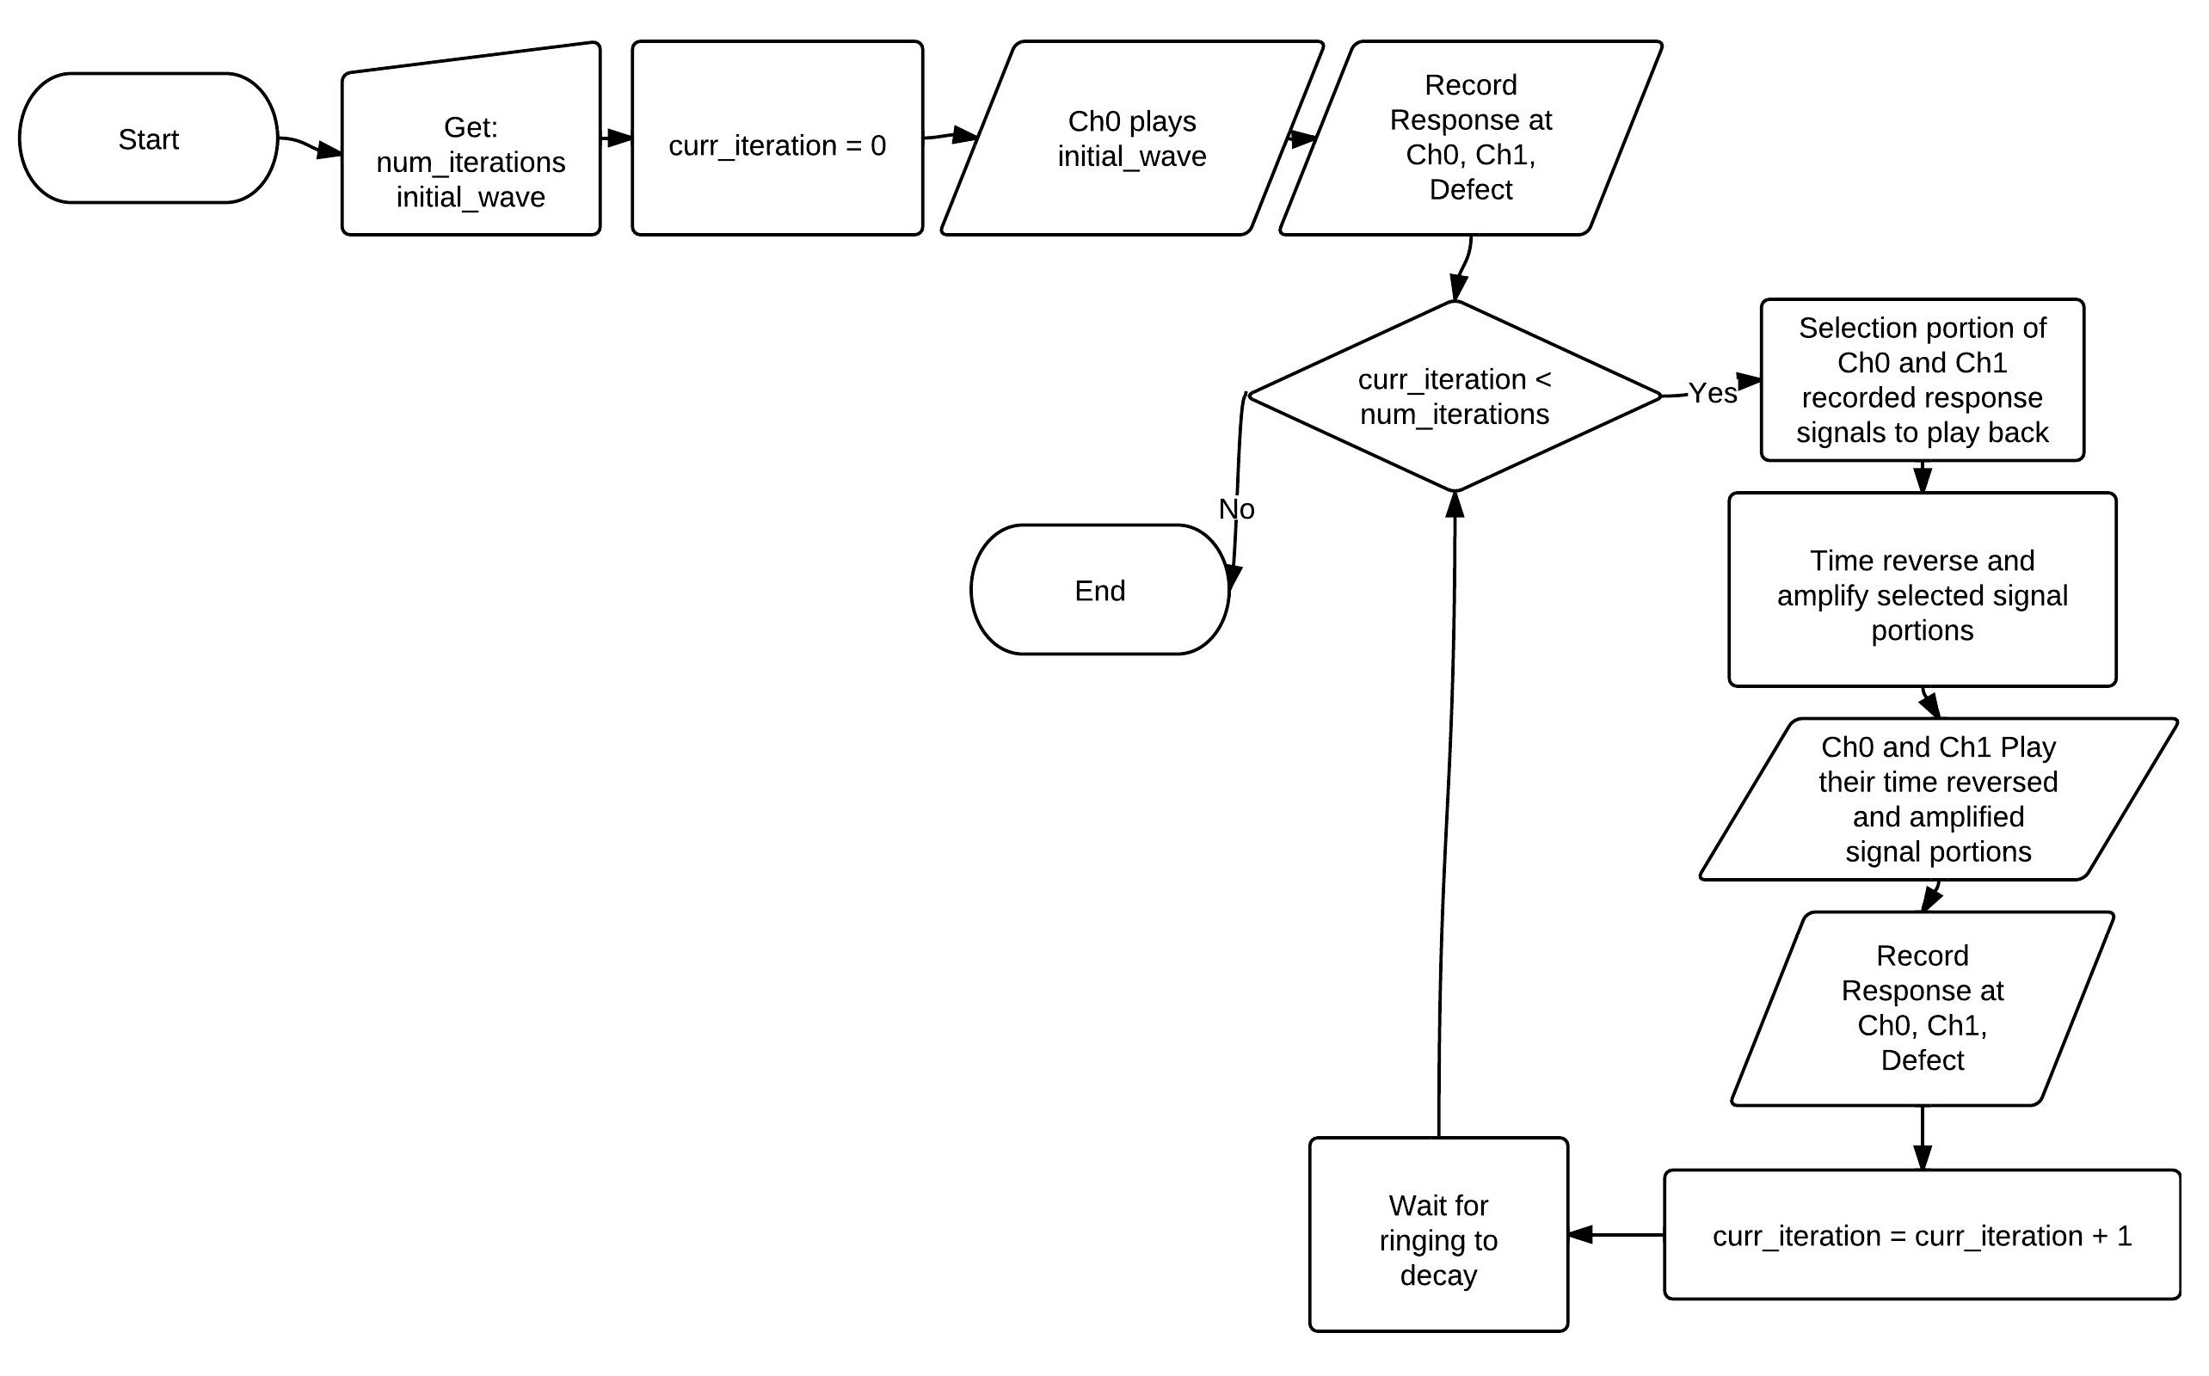
Figure 2 Flowchart for the time reversal algorithm

For the steel rod tests, Figure 3 shows the signal that is recorded at the defect PZT on the first iteration, as well as a windowed RMS of that signal. You will see that the windowed RMS essentially just puts fits a line around the waves seen in the defect signal. The first wave seen is the first occurrence of the initial pulse at the defect. Each subsequent wave is a reflection of that initial wave within the system. The RMS amplitude of the first peak is seen to be about 1.2 volts.
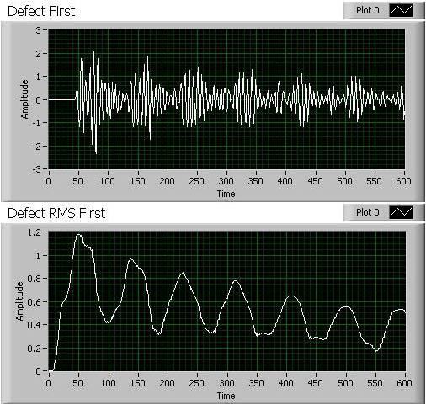
Figure 3 (Steel rods) Signal read on first iteration at the defect (top) and a windowed RMS of that signal (bottom)

In Figure 4 we have the signal recorded at the defect PZT for the steel rod tests after the time reversal algorithm has converged. We also plot the windowed RMS of that signal in Figure 4. You will now see that the first peak in the signal has grown much more rapidly than the rest of the peaks seen in the signal. The RMS amplitude of the first peak is now almost 3.5 volts, which is nearly a 3 fold increase over the first iteration.

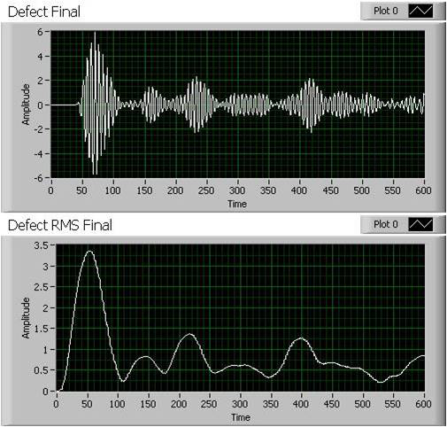
Figure 4 (Steel rods) Signal read at the defect after convergence (top) and a windowed RMS of that signal (bottom)

Figure 5 shows the amplitude seen at the defect for each iteration. Notice the fast growth and then leveling out as the algorithm converges to a solution.

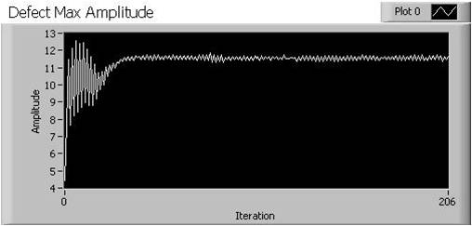
Figure 5 (Steel rods) Amplitudes seen at the defect for each iteration of the time reversal

The same tests were performed using nylon rods. This shows that the time reversal algorithm will also work in dispersive media (versus the nicely transmitting steel). Similar results are seen. Figure 6 shows the signal recorded at the defect on the first iteration, as well as a windowed RMS of that signal. Notice that we do not have all of the reflection waves in the nylon like we saw in the steel. The first peak is seen to have an RMS amplitude of about 0.08 volts.

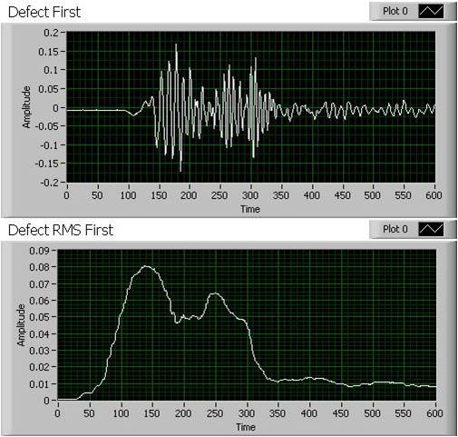
Figure 6 (Nylon rods) Signal recorded at the defect PZT on the first iteration (top), and a windowed RMS of that signal (bottom)

Figure 7 shows the response at the defect after the time reversal algorithm has converged. Notice again that the first peak has grown much more rapidly that the other peaks in the signal. The RMS amplitude of the first peak is now over 0.4 volts, a 5 fold increase over the first iteration.

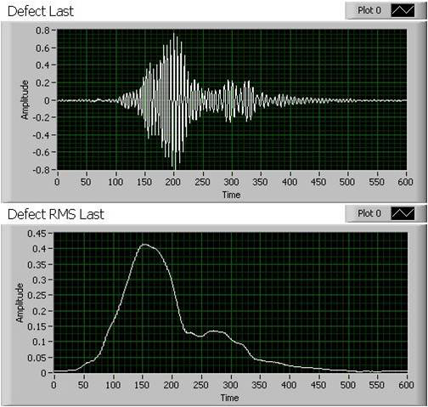
Figure 7 (Nylon rods) Signal recorded at the defect PZT after convergence (top), and a windowed RMS of that signal (bottom)

Figure 8 shows the amplitudes recorded at the defect PZT for each iteration. Again, we see that the amplitude increases quickly and then levels off as the algorithm converges.

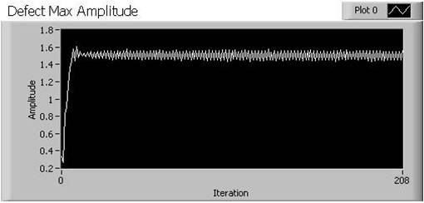
Figure 8 (Nylon rods) Amplitudes seen at the defect for each iteration of the time reversal

So we have seen very good results using the new iterative time reversal algorithm. Our future work is to attempt the time reversal in multiple dimensions, as well as combine it with the epoxy curing experiments in an attempt to accelerate the curing process of that epoxy.

